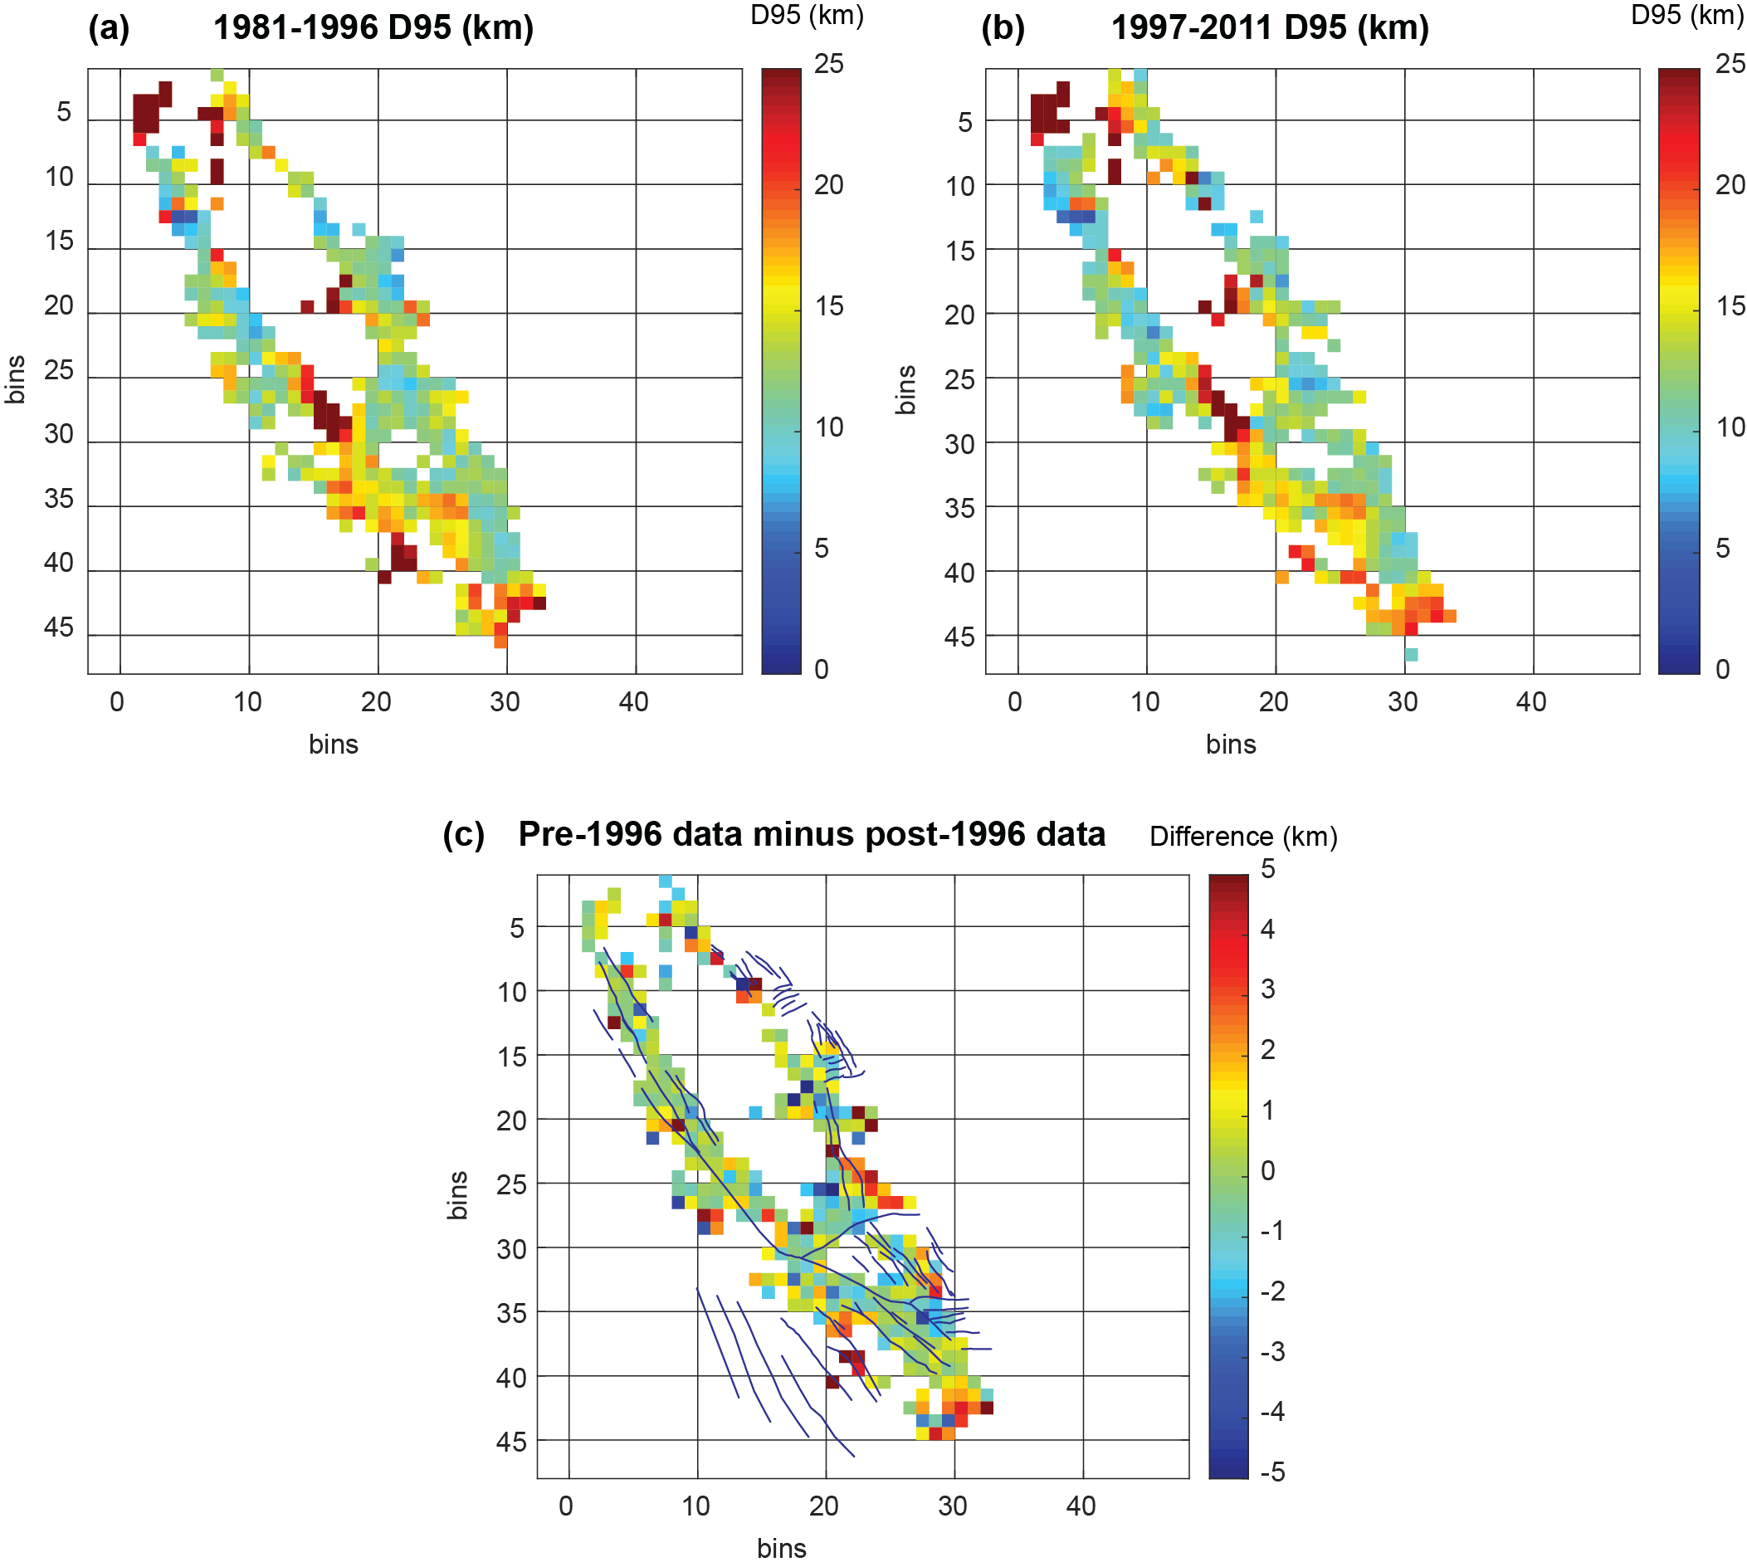
Supplemental Figure 1. Investigation of temporal variations in seismogenic thickness maps. Comparison uses 25 km bin width, is filtered for bins containing >50 earthquakes, and is presented in bin number x-y coordinates. (a) D95 map using earthquakes from 1981 to 1996, (b) D95 map using earthquakes from 1997 to 2011, and (c) difference between pre-1996 and post-1996 datasets with basic faults overlain for spatial context. Note that there are only a few significant variations in between the two time periods, and no obvious systematic change in the seismogenic thickness map. The average absolute variation from all pixels is 1.5 km.

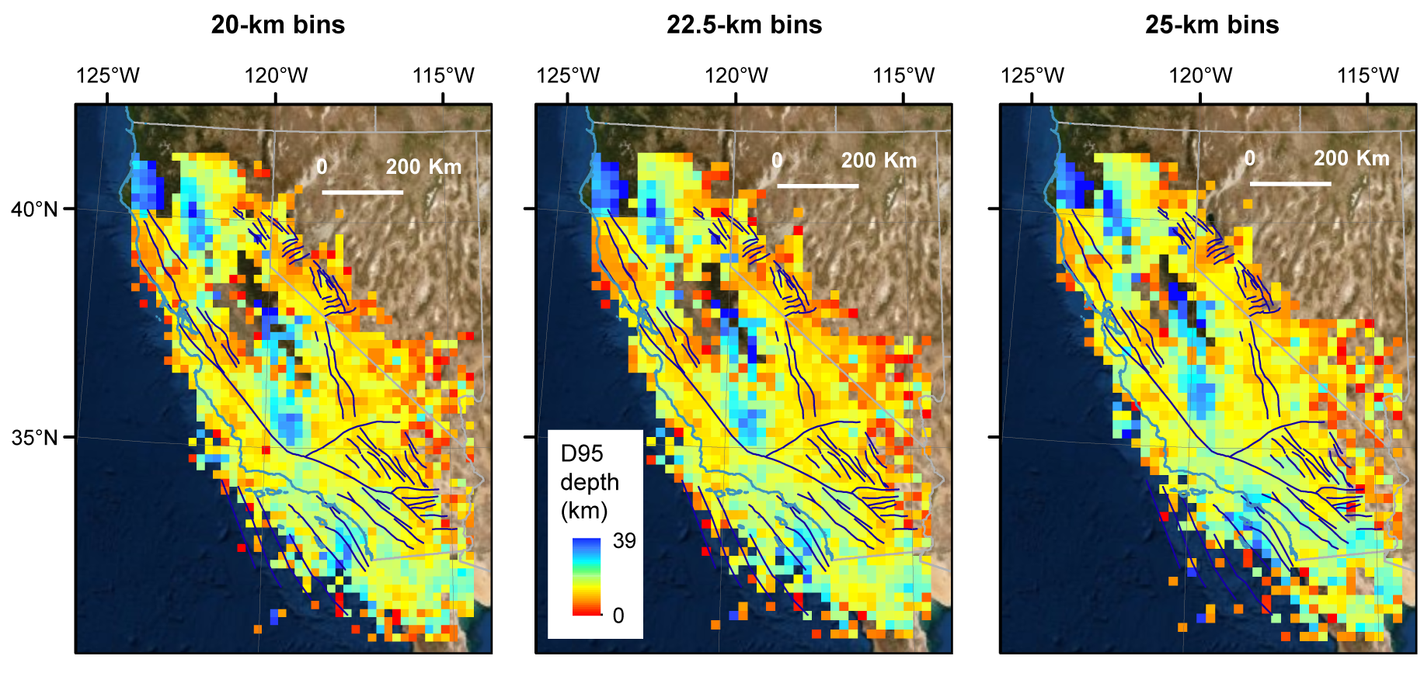
Supplemental Figure 2. Unfiltered D95 maps for three bin widths. Figure 3 of main text presents filtered maps. The broad structures of the filtered and unfiltered maps are very similar.

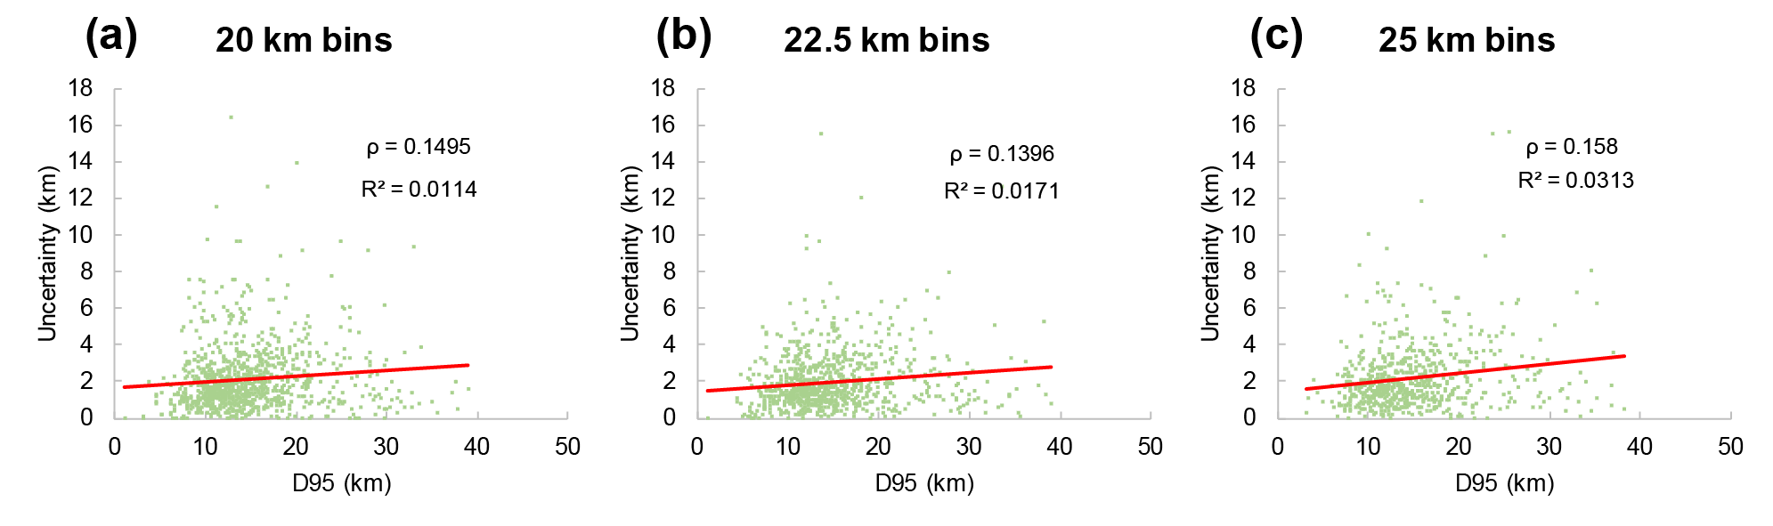
Supplemental Figure 3. Comparison of uncertainty and D95 depth, per bin, showing no systematic correlation between greater uncertainties and thicker D95 depths. R² and Spearman's rank correlation coefficient ρ shown. Also note that most uncertainty points are < 5 km. The flat linear fit implies that the percentage error of a given D95 value decreases with depth.
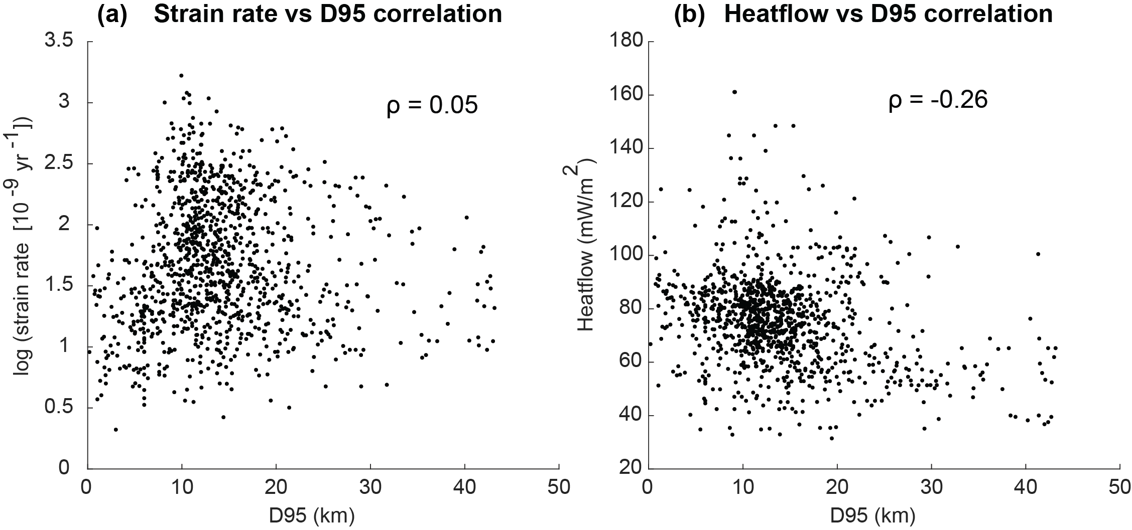
Supplemental Figure 4. Correlations between D95 and (a) strain rate (Kreemer et al., 2014) and (b) heat flow observations (Blackwell et al., 2011). All data was resampled to 22.5 km bin width, and correlation assessed with Spearman's rank correlation coefficient ρ. Note the lack of correlation between strain rate and D95, and the moderate negative correlation between heat flow and D95, as discussed in the text. The negative correlation between heat flow and D95 implies thinner seismogenic crust for a hotter thermal structure, as expected.
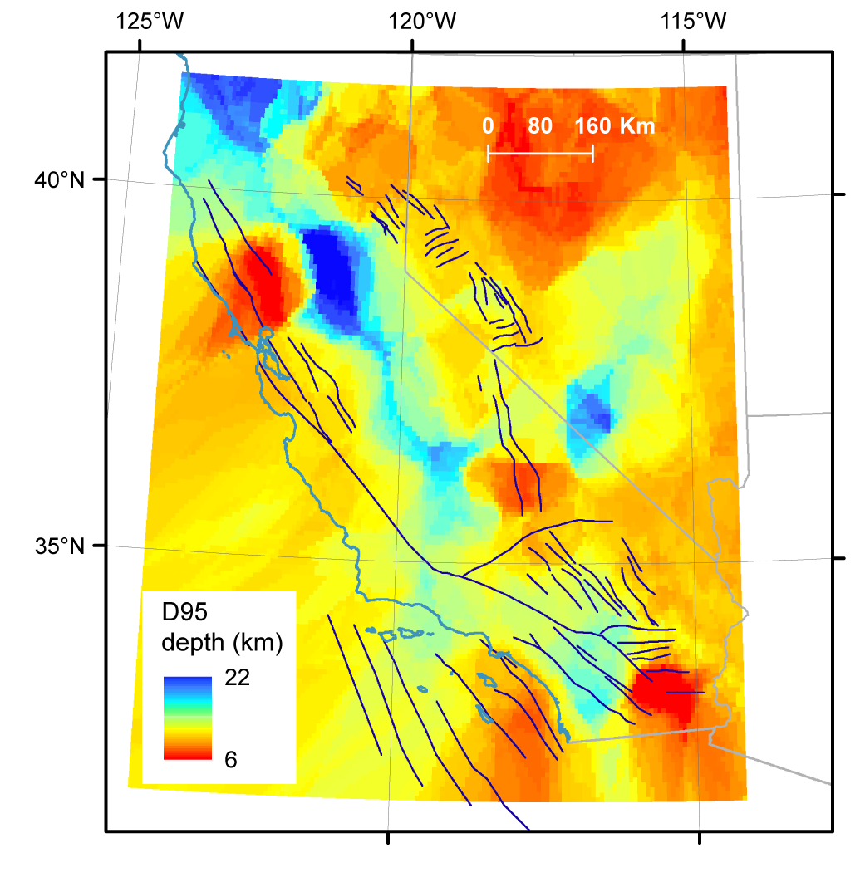
Supplemental Figure 5. Inverted D95 map using data from surface heat flow data from Blackwell et al. (2011). Methods of inversion are described in the main text, and Figure 7b shows the difference between this inverted D95 map (resampled to 22.5 km bin width) and the earthquake-derived D95 map of Figure 3.

