Supplementary Material
Diachronous Uplift in Intra-continental Orogeny: 2D Thermo-Mechanical Modeling of the India-Asia collision
Shuang Bian¹, Junfeng Gong¹*, Lin Chen²*, Andrew V. Zuza³, Hanlin Chen¹, Xiubin Lin¹, Xiaogan Cheng¹, and Rong Yang¹
¹ School of Earth Sciences, Zhejiang University, Hangzhou 310027, China
² Institute of Geology and Geophysics, Chinese Academy of Sciences, Beijing 100029, China
³ Nevada Bureau of Mines and Geology, University of Nevada, Reno, Nevada 89557, USA
Corresponding author: Junfeng Gong (jfgong@zju.edu.cn)
Corresponding author: Lin Chen (chenlin@mail.iggcas.ac.cn)

Table A.1 Summary of the onset timing of ranges uplift
Name | Age(Ma) | Methods | References
South Tian Shan | ~36 | seismostratigraphy, paleomagnetism | Zhang et al., 2014
 | ~30-25 | zircon (U-Th)/He, apatite fission track | Glorie et al., 2011
 | ~26 | magnetostratigraphy | Li et al., 2019b
 | ~26-25 | growth strata | Wang et al., 2011
 | ~25 | apatite fission track | Sobel and Dumitru, 1997
 | ~25 | apatite (U-Th)/He, apatite fission track | Jepson et al., 2017
 | ~24 | apatite fission track | Hendrix et al., 1994
 | ~24 | apatite fission track | Sobel et al., 2006
 | ~24-21 | growth strata | Yin et al., 1998
 | ~17 | acceleration of sediment flux | Métivier and Gaudemer, 1997
 | ~17-16 | magnetostratigraphy | Huang et al., 2006
 | ~16.3 | growth strata | Heermance et al., 2007
 | ~16 | crustal shortening | Avouac et al., 1993
 | ~16-15 | magnetostratigraphy | Charreau et al., 2009
 | ~13 | seismostratigraphy, paleomagnetism | Zhang et al., 2014
 | ~11 | magnetostratigraphy | Charreau et al., 2006
 | ~7 | magnetostratigraphy | Huang et al., 2006
 | ~6.5 | seismostratigraphy, paleomagnetism | Zhang et al., 2014
 | ~2.6 | seismostratigraphy, paleomagnetism | Zhang et al., 2014
North Tian Shan | ~11 | apatite fission track, (U-Th)/He | Bullen et al., 2001
 | ~11-10 | apatite fission track, (U-Th)/He | Bullen et al., 2003
 | ~10.5 | magnetostratigraphy | Charreau et al., 2005
 | ~10-8 | apatite fission track, (U-Th)/He | Glorie et al., 2010
West Kunlun | ~23 | palaeo-environment | Jiang and Li, 2014
 | ~22 | apatite fission track | Cowgill, 2001
 | ~20 | apatite fission track | Sobel and Dumitru, 1997
 | ~20 | apatite fission track | Wang et al., 2003b
 | ~16-15 | apatite fission track, (U-Th)/He | Ritts et al., 2008
 | ~15 | Nd isotopic analysis | Li et al., 2011
 | ~4.5 | palaeo-environment | Zheng et al., 2000; 2006
 | ~4 | palaeo-environment | Tada et al., 2010
Qilian Shan | ~66-50 | growth strata | Yin et al., 2008
 | ~65-50 | K-feldspars ⁴⁰Ar/³⁹Ar | Zhuang et al., 2018
 | ~60-45 | apatite and zircon (U-Th)/He and fission-track | Zuza et al., 2016; 2019
 | ~55 | apatite fission track | Qi et al., 2016
 | ~55-40 | sedimentary record | Zhuang et al., 2011
 | ~50-30 | apatite fission track | Zhang et al., 2015
 | ~50-30 | apatite fission track | Jolivet et al., 2001
 | ~33 | apatite fission track | Yin et al., 2002
Continued Table A.1
Qilian Shan | ~27 | apatite fission track, stratigraphy | Guo et al., 2009
 | ~25 | apatite fission track | Lu et al., 2002
 | ~20 | apatite and zircon (U-Th)/He | Shi et al., 2018
 | ~15-10 | apatite fission track | Li et al., 2019a
 | ~14 | magnetostratigraphy | Sun et al., 2005
 | ~13 | sedimentary record | Bovet et al., 2009
 | ~12 | sedimentary record | Wang et al., 2003a
 | ~10 | apatite (U-Th)/He | Zheng et al., 2010
 | ~10 | apatite fission track | Zheng et al., 2017
East Kunlun | ~40 | ⁴⁰Ar/³⁹Ar and apatite (U-Th)/He | Wang et al., 2016
 | ~35 | K-feldspars and Biotite ⁴⁰Ar/³⁹Ar, apatite fission track | Wang et al., 2004
 | ~35 | apatite (U-Th)/He | Clark et al., 2010
 | ~32 | ⁴⁰Ar/³⁹Ar | Liu et al., 2005
 | ~30 | K-feldspars 40Ar/39A | Mock et al., 1999
 | ~30-20 | apatite and zircon (U-Th)/He, apatite fission track | Duvall et al., 2013
 | ~30-20 | apatite and zircon fission track | McRivette et al., 2019
 | ~29-24 | growth strata | Yin et al., 2008
 | ~28-24 | growth strata | Yin et al., 2007
 | ~20 | apatite fission track | Wu et al., 2019
 | ~20 | apatite fission track | Yuan et al., 2003
 | ~20 | apatite fission track | Yuan et al., 2006
 | ~20 | apatite fission track | Lewis, 1990
 | ~19 | apatite fission track | Jolivet et al., 2001
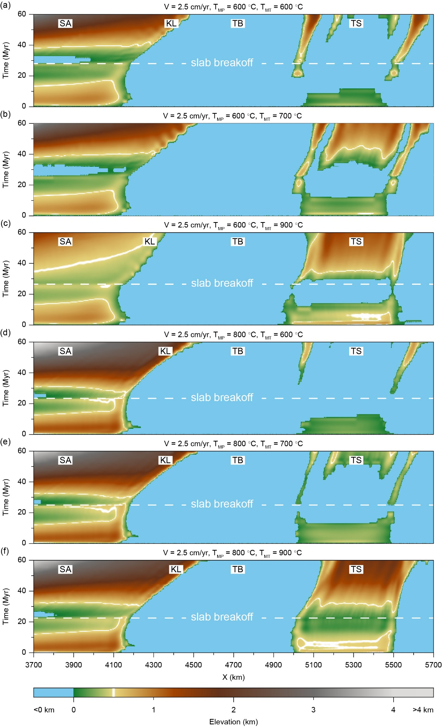
Figure A.1. Topographic evolution of the models outside the text in the Figure 11a.
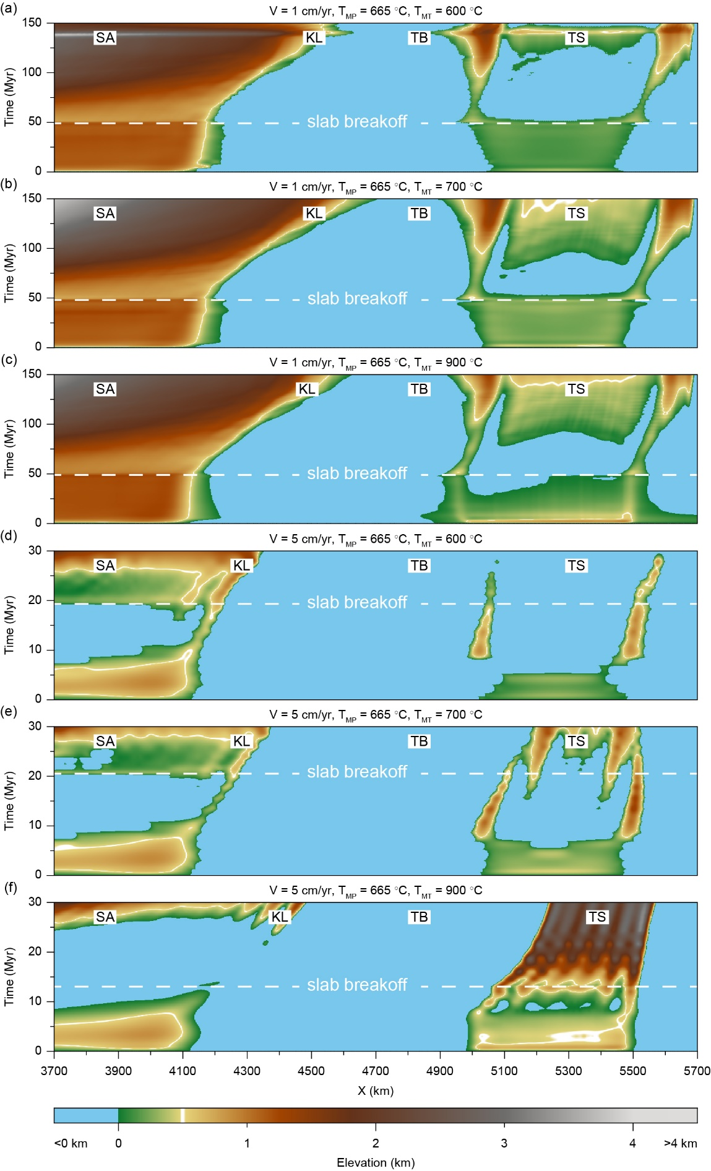
Figure A.2. Topographic evolution of the models outside the text in the Figure 11b.
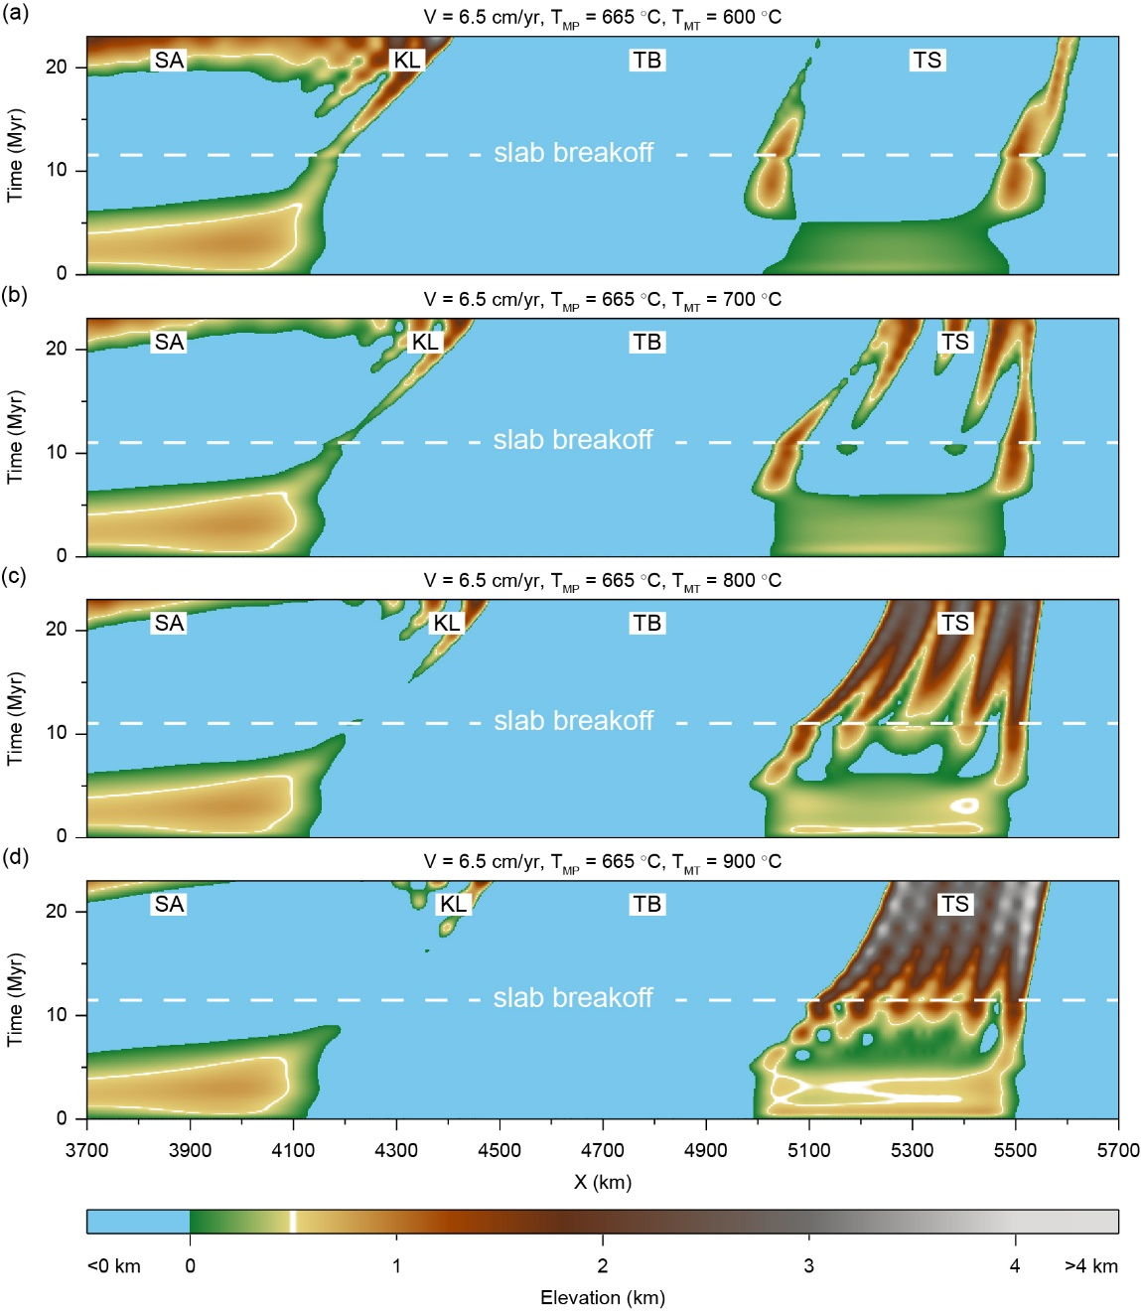

Figure A.3. Topographic evolution of the models with higher convergence rate (V = 6.5 cm/yr). The higher convergence rate facilitates the build-up of topography, and yields more pronounced uplift difference between the West Kunlun and Tian Shan in the diachronous rise mode. The results reveal that an increased convergence rate is beneficial to the diachronous mode of intracontinental orogeny under the far-field effect of Indian-Asian collision.
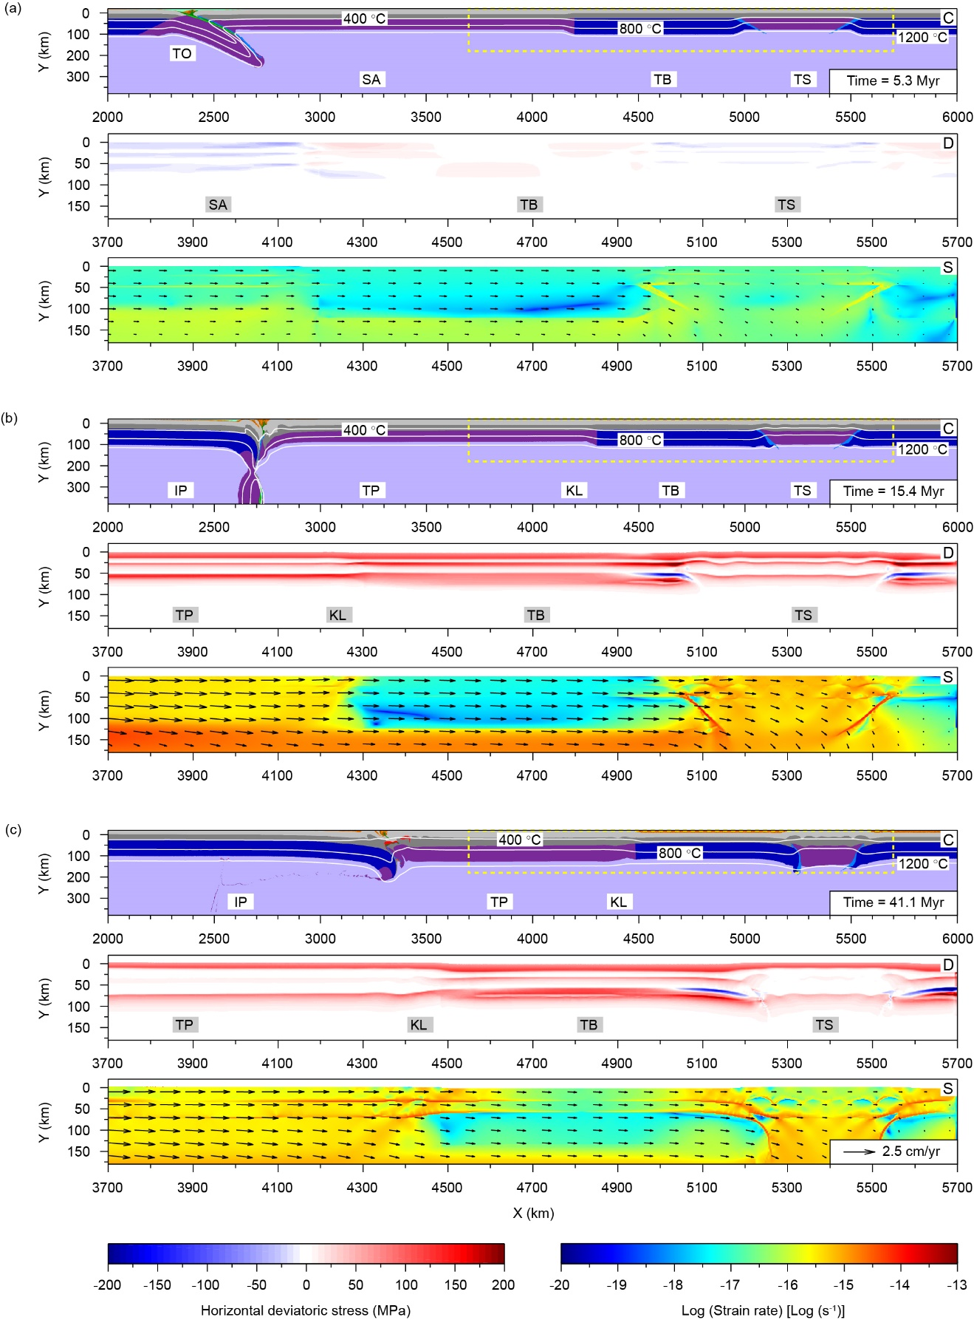
Figure A.4. Temporal evolution of the model with a changing convergence rate. The convergence rate is 5 cm/yr in the first 15 Myr, and then decreases to 2.5 cm/yr during the subsequent 5 Myr and keeps constant for the following processes. The snapshots are the composition fields, horizontal deviatoric stress and strain rate distribution of the whole process, which shows the same stages as in the reference model: (a) subduction of Tethys Ocean, (b) continental collision and (c) intraplate orogeny.

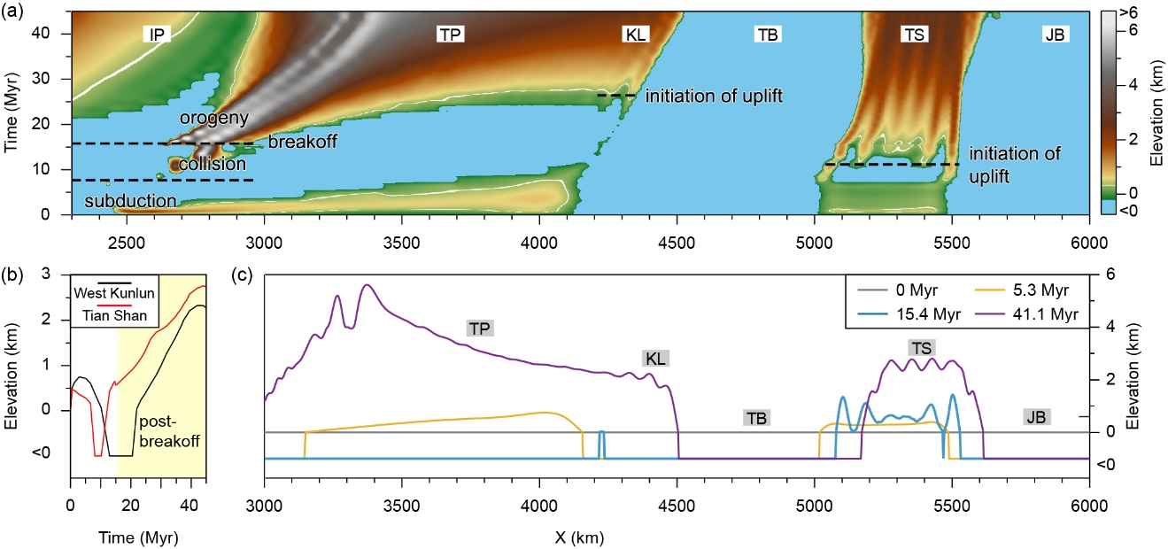
Figure A.5. Results with respect to a changing convergence rate. (a) Topography evolution with time. The time when elevation reaches 500 m represents the initiation of uplift (white-colored contour line), and in this case Tian Shan uplifted earlier than that of West Kunlun range, demonstrating a diachronous rise pattern. (b) Topographic profiles of the Tian Shan and the West Kunlun. Light yellow-colored region represents post-breakoff stage. (c) Snapshots of topography distribution at 0, 5.3, 15.4 and 41.1 Myr, respectively. The result is a combination of the Model a (2.5 cm/yr) and the Model c (5 cm/yr). It yields diachronous rise mode, where the uplift difference of the Tian Shan and the West Kunlun is larger than that in the Model a, and the elevation of the West Kunlun is significantly higher than that in the Model c.

References:
Avouac, J. P., Tapponnier, P., Bai, M., You, H., Wang, G., 1993. Active thrusting and folding along the northern Tien Shan and Late Cenozoic rotation of the Tarim relative to Dzungaria and Kazakhstan. J. Geophys. Res., 98(B4), 6755-6804. https://doi.org/10.1029/92JB01963.
Bovet, P. M., Ritts, B. D., Gehrels, G., Abbink, A. O., Darby, B., Hourigan, J., 2009. Evidence of Miocene crustal shortening in the north Qilian Shan from Cenozoic stratigraphy of the western Hexi corridor, Gansu province, China. Am. J. Sci., 309(4), 290-329. https://doi.org/ 10.2475/00.4009.02.
Bullen, M. E., Burbank, D. W., Garver, J. I., 2003. Building the northern Tien Shan: integrated thermal, structural, and topographic constraints. J. Geol., 111(2), 149-165. https://doi.org/10.1086/345840.
Bullen, M. E., Burbank, D. W., Garver, J. I., Abdrakhmatov, K. Y., 2001. Late Cenozoic tectonic evolution of the northwestern Tien Shan: New age estimates for the initiation of mountain building. Geol. Soc. Amer. Bull., 113(12), 1544-1559. https://doi.org/10.1130/0016-7606(2001)113<1544:LCTEOT>2.0.CO;2.
Charreau, J., Chen, Y., Gilder, S., Barrier, L., Dominguez, S., Augier, R., Sen, S., Avouac, J. P., Gallaud, A., Graveleau, F., Wang, Q. C., 2009. Neogene uplift of the Tian Shan Mountains observed in the magnetic record of the Jingou River section (northwest China. Tectonics, 28(2), 224-243. https://doi.org/10.1029/2007TC002137.
Charreau, J., Chen, Y., Gilder, S., Dominguez, S., Avouac, J. P., Sen, S., Sun, D. J., Li, Y. A., Wang, W., M., 2005. Magnetostratigraphy and rock magnetism of the neogene kuitun he section (northwest china): implications for late Cenozoic uplift of the Tianshan mountains. Earth Planet. Sci. Lett., 230(1-2), 177-192. https://doi.org/10.1016/j.epsl.2004.11.002.
Charreau, J., Gilder, S., Chen, Y., Dominguez, S., Avouac, J. P., Sen, S., Jolivet, M., Li, Y. A., Wang, W., M., 2006. Magnetostratigraphy of the Yaha section, Tarim basin (China): 11 Ma acceleration in erosion and uplift of the Tian Shan mountains. Geology, 34(3), 181-184. https://doi.org/10.1130/G22106.1.
Clark, M. K., Farley, K. A., Zheng, D. W., Wang, Z. C., Duvall, A. R., 2010. Early Cenozoic faulting of the northern Tibetan Plateau margin from apatite (U-Th)/He ages. Earth Planet. Sci. Lett., 296(1-2), 78-88. https://doi.org/10.1016/j.epsl.2010.04.051.
Cowgill, E. S., 2001. Tectonic evolution of the Altyn Tagh-western Kunlun fault system, northwestern China, Doctoral dissertation. Los Angeles: University of California.
Duvall, A. R., Clark, M. K., Kirby, E., Farley, K. A., Craddock, W. H., Li, C. Y., Yuan, D. Y., 2013. Low-temperature thermochronometry along the Kunlun and Haiyuan faults, NE Tibetan plateau: Evidence for kinematic change during late-stage orogenesis. Tectonics, 32(5), 1190-1211. https://doi.org/10.1002/tect.20072.
Glorie, S., De Grave, J., Buslov, M. M., Zhimulev, F. I., Stockli, D. F., Batalev, V. Y., Lzmer, A., Van dem haute, P., Vanhaecke, F., Elburg, M. A., 2011. Tectonic history of the Kyrgyz South Tien Shan (Atbashi-Inylchek) suture zone: The role of inherited structures during deformation-propagation. Tectonics, 30(6), TC6016. https://doi.org/10.1029/2011TC002949.
Glorie, S., Grave, J. D., Buslov, M. M., Elburg, M. A., Stockli, D. F., Gerdes, A., Van dem haute, P., 2010. Multi-method chronometric constraints on the evolution of the Northern Kyrgyz Tien Shan granitoids (central Asian orogenic belt): From emplacement to exhumation. J. Asian Earth Sci., 38(3-4), 131-146. https://doi.org/10.1016/j.jseaes.2009.12.009.
Guo, Z. J., Jiemin, L. U., Zhang, Z. C., 2009. Cenozoic exhumation and thrusting in the northern Qilian Shan, northeastern margin of the Tibetan plateau: constraints from sedimentological and apatite fission‐track data. Acta Geol. Sin. -Engl., 83(3), 562-579. https://doi.org/10.1111/j.1755-6724.2009.00045.x.
Heermance, R. V., Chen, J., Burbank, D. W., Wang, C. S., 2007. Chronology and tectonic controls of late tertiary deposition in the southwestern Tian Shan foreland, NW China. Basin Res., 19(4), 599-632. https://doi.org/10.1111/j.1365-2117.2007.00339.x.
Hendrix, M. S., Dumitru, T. A., Graham, S. A., 1994. Late Oligocene-early Miocene unroofing in the Chinese Tian Shan: an early effect of the India-Asia collision. Geology, 22(6), 487-490. https://doi.org/10.1130/0091-7613(1994)022<0487:LOEMUI>2.3.CO;2.
Huang, B. C., Piper, J. D. A., Peng, S. T., Liu, T., Li, Z., Wang, Q. C., Zhu, R, X., 2006. Magnetostratigraphic study of the Kuche depression, Tarim Basin, and Cenozoic uplift of the Tian Shan Range, Western China. Earth Planet. Sci. Lett., 251(3-4), 346-364. https://doi.org/10.1016/j.epsl.2006.09.020.
Jepson, G., Glorie, S., Konopelko, D., Gillespie, J., Danišík, Martin, Evans, N. J., Mamadjanov, Y., Collins, A. S., 2017. Thermochronological insights into the structural contact between the Tian Shan and Pamirs, Tajikistan. Terra Nova, 30(2), 95-104. https://doi.org/10.1111/ter.12313.
Jiang, X. D., Li, Z. X., 2014. Seismic reflection data support episodic and simultaneous growth of the Tibetan Plateau since 25 Myr. Nat. Commun., 5, 5453. https://doi.org/10.1038/ncomms6453.
Jolivet, M., Brunel, M., Seward, D., Xu, Z., Yang, J., Roger, F., Tapponnier, P., Malavieille, J., Arnaud, N., Wu, C., 2001. Mesozoic and Cenozoic tectonics of the northern edge of the Tibetan Plateau: Fission-track constraints. Tectonophysics, 343(1), 111-134. https://doi.org/10.1016/S0040-1951(01)00196-2.
Lewis, C. L. E. (1990). Thermal history of the Kunlun batholith, N. Tibet, and implications for uplift of the Tibetan plateau. Nucl. Tracks Radiat. Meas., 17(3), 301-307.
Lewis, C. L. E., 1990. Thermal history of the Kunlun batholith, N. Tibet, and implications for uplift of the Tibetan plateau. Nucl. Tracks Radiat. Meas., 17(3), 301-307. https://doi.org/10.1016/1359-0189(90)90050-8.
Li, B., Chen, X. H., Zuza, A. V., Hu, D. G., Ding, W. C., Huang, P. H., Xu, S. L., 2019a. Cenozoic cooling history of the North Qilian Shan, northern Tibetan Plateau and the initiation of the Haiyuan fault: Constraints from apatite- and zircon fission track thermochronology. Tectonophysics, 751, 109-124. https://doi.org/10.1016/j.tecto.2018.12.005.
Li, G., Pettke, T., Chen, J., 2011. Increasing Nd isotopic ratio of Asian dust indicates progressive uplift of the north Tibetan Plateau since the middle Miocene. Geology, 39(3), 199-202. https://doi.org/10.1130/g31734.1.
Li. C., Wang, A. L., Wang, L. S., 2019b. Tectonostratigraphic history of the southern Tian Shan, western China, from seismic reflection profiling. J. Asian Earth Sci., 172, 101-114. https://doi.org/10.1016/j.jseaes.2018.08.017.
Liu, Y. J., Genser, J., Neubauer, F., Jin, W., Ge, X., H. Handler, R., Takasu, A., 2005. ⁴⁰Ar/³⁹Ar mineral ages from basement rocks in the Eastern Kunlun Mountains, NW china, and their tectonic implications. Tectonophysics, 398(3-4), 199-224. https://doi.org/10.1016/j.tecto.2005.02.007.
Lu, H. J., Wang, E., Shi, X. H., Meng, K., 2012. Cenozoic tectonic evolution of the Elashan range and its surroundings, northern Tibetan Plateau as constrained by paleomagnetism and apatite fission track analyses. Tectonophysics, 580, 150-161. https://doi.org/10.1016/j.tecto.2012.09.013.
McRivette, M. W., Yin, A., Chen, X. H., Gehrels, G. E., 2019. Cenozoic basin evolution of the central Tibetan plateau as constrained by U-Pb detrital zircon geochronology, sandstone petrology, and fission-track thermochronology. Tectonophysics, 751, 150-179. https://doi.org/10.1016/j.tecto.2018.12.015.
Métivier, F., Gaudemer, Y., 1997. Mass transfer between eastern Tien Shan and adjacent basins (central Asia): constraints on regional tectonics and topography. Geophys. J. Int., 128(1), 1-17.
Mock, C., Arnaud, N. O., Cantagrel, J. M., 1999. An early unroofing in northeastern Tibet? Constraints from ⁴⁰Ar/³⁹Ar thermochronology on granitoids from the eastern Kunlun range (Qianghai, NW China. Earth Planet. Sci. Lett., 171(1), 107-122. https://doi.org/10.1016/s0012-821x(99)00133-8.
Qi, B. S., Hu, D. G., Yang, X. X., Zhang, Y. L., Tan, C. X., Zhang, P., Feng, C. J., 2016. Apatite fission track evidence for the Cretaceous-Cenozoic cooling history of the Qilian Shan (NW China) and for stepwise northeastward growth of the northeastern Tibetan Plateau since early Eocene. J. Asian Earth Sci., 124, 28-41. https://doi.org/10.1016/j.jseaes.2016.04.009.
Ritts, B. D., Yue, Y., Graham, S. A., Sobel, E. R., Abbink, O. A., Stockli, D., 2008. From sea level to high elevation in 15 million years: Uplift history of the northern Tibetan plateau margin in the Altun Shan. Am. J. Sci., 308(5), 657-678. https://doi.org/10.2475/05.2008.01.
Shi, W. B., Wang, F., Yang, L, Y., Wu, L., Zhang, W. B., 2018. Diachronous growth of the Altyn Tagh Mountains: Constraints on Propagation of the Northern Tibetan margin from (U-Th)/He dating. J. Geophys. Res., 123, 6000-6018. https://doi.org/10.1029/2017JB014844.
Sobel, E. R., Dumitru, T. A., 1997. Thrusting and exhumation around the margins of the western Tarim basin during the India-Asia collision. J. Geophys. Res., 102(B3), 5043-5063. https://doi.org/10.1029/96jb03267.
Sobel, E. R., Chen, J., Heermance, R. V., 2006. Late Oligocene-Early Miocene initiation of shortening in the Southwestern Chinese Tian Shan: Implications for Neogene shortening rate variations. Earth Planet. Sci. Lett., 247(1-2), 70-81. https://doi.org/10.1016/j.epsl.2006.03.048.
Sun, J. M., Zhu, R. X., An, Z. S., 2005. Tectonic uplift in the northern Tibetan plateau since 13.7 Ma ago inferred from molasse deposits along the Altyn Tagh Fault. Earth Planet. Sci. Lett., 235(3-4), 641-653. https://doi.org/10.1016/j.epsl.2005.04.034.
Tada, R., Zheng, H. B., Sugiura, N., Isozaki, Y., Hasegawa, H., Sun, Y. B., Yang, W. G., Wang, K., Toyoda, S., 2010. Desertification and dust emission history of the Tarim basin and its relation to the uplift of northern Tibet. Geol. Soc. London Spec. Publ. 342(1), 45-65. https://doi.org/10.1144/SP342.5.
Wang, E., Wan, J. L., Liu, J. Q., 2003b. Late Cenozoic geological evolution of the foreland basin bordering the West Kunlun range in Pulu area: Constraints on timing of uplift of northern margin of the Tibetan Plateau. J. Geophys. Res., 108(B8), 2401. https://doi.org/10.1029/2002jb001877.
Wang, F., Feng, H. L., Shi, W. B., Zhang, W. B., Wu, L., Yang, L. K., Wang, Y. Z., Zhang, Z. G., Zhu, R. X., 2016. Relief history and denudation evolution of the northern Tibet margin: constraints from ⁴⁰Ar/³⁹Ar and (U-Th)/He dating and implications for far-field effect of rising plateau. Tectonophysics, 675, 196-208. https://doi.org/10.1016/j.tecto.2016.03.001.
Wang, F., Lo, C. H., Li, Q., Yeh, M. W., Wan, J. L., Zheng, D. W., Wang, E., 2004. Onset timing of significant unroofing around Qaidam basin, northern Tibet, China: constraints from ⁴⁰Ar/ ³⁹Ar and FT thermochronology on granitoids. J. Asian Earth Sci., 24(1), 59-69. https://doi.org/10.1016/j.jseaes.2003.07.004.
Wang, X. M., Wang, B. Y., Qiu, Z. X., Xie, G. P., Xie, J. Y., Downs, W., et al., 2003a. Danghe area (western Gansu, China) biostratigraphy and implications for depositional history and tectonics of northern Tibetan Plateau. Earth Planet. Sci. Lett., 208(3-4), 253-269. https://doi.org/10.1016/s0012-821x(03)00047-5.
Wang, X., Suppe, J., Guan, S. W., Hubert-Ferrari, A., Gonzalez-Mieres, R., Jia, C. Z., 2011. Cenozoic structure and tectonic evolution of the Kuqa fold belt, southern Tianshan, China. AAPG Mem., 215-243. https://doi.org/10.1306/13251339M94389.
Wu, C., Zuza, A. V., Zhou, Z. G., Yin, A, McRivette, M. W., Chen, X. H., Ding, L., Geng, J. Z., 2019. Mesozoic-Cenozoic evolution of the Eastern Kunlun Range, central Tibet, and implications for basin evolution during the Indo-Asian collision. Lithosphere. 11(4), 524-550. https://doi.org/0000-0003-0647-3530.
Yin, A., Dang, Y. Q., Zhang, M., Chen, X. H., McRivette, M. W., 2008. Cenozoic tectonic evolution of the Qaidam basin and its surrounding regions (Part 3): structural geology, sedimentation, and regional tectonic reconstruction. Geol. Soc. Am. Bull., 120(7-8), 847-876. https://doi.org/10.1130/B26232.1.
Yin, A., Dang, Y. Q., Zhang, M., McRivette, M. W., Burgess, W. P., Chen, X. H., 2007. Cenozoic tectonic evolution of qaidam basin and its surrounding regions (Part 2): wedge tectonics in southern Qaidam basin and the Eastern Kunlun range. Geol. Soc. Am. Spec., 433, 369-390. https://doi.org/10.1130/2007.2433(18).
Yin, A., Nie, S., Craig, P., Harrison, T. M., Ryerson, F. J., Qian, X. L., Geng, Y., 1998. Late Cenozoic tectonic evolution of the southern Chinese Tian Shan. Tectonics, 17(1), 1-27. https://doi.org/10.1029/97tc03140.
Yin, A., Rumelhart, P. E., Butler, R., Cowgill, E., Harrison, T. M., Foster, D. A., Ingersoll, R. V., Zhang, Q., Zhou, X. Q., Wang, X. F., Hanson, A., Raza, A., 2002. Tectonic history of the Altyn Tagh Fault system in northern Tibet inferred from Cenozoic sedimentation. Geol. Soc. Am. Bull., 114(10), 1257-1295. https://doi.org/10.1130/0016-7606(2002)114<1257:THOTAT>2.0.CO;2.
Yuan, W. M., Zhang, X. T., Dong, J. Q., Tang, Y. H., Yu, F. S., Wang, S. C., 2003. A new vision of the intracontinental evolution of the eastern Kunlun Mountains, Northern Qinghai-Tibet plateau, China. Radiat. Meas., 36(1-6), 357-362. https://doi.org/10.1016/s1350-4487(03)00151-3.
Yuan, W., Dong, J., Shicheng, W., Carter, A., 2006. Apatite fission track evidence for Neogene uplift in the eastern Kunlun Mountains, northern Qinghai-Tibet Plateau, China. J. Asian Earth Sci., 27(6), 847-856. https://doi.org/10.1016/j.jseaes.2005.09.002.
Zhang, J., Wang, Y. N., Zhang, B. H., Zhao, H., 2015. Evolution of the NE Qinghai-Tibetan Plateau, constrained by the apatite fission track ages of the mountain ranges around the Xining Basin in NW China. J. Asian Earth Sci., 97, 10-23. https://doi.org/10.1016/j.jseaes.2014.10.002.
Zhang, T., Fang, X. M., Song, C. H., Appel, E., Wang, Y. D., 2014. Cenozoic tectonic deformation and uplift of the south Tian Shan: implications from magnetostratigraphy and balanced cross-section restoration of the Kuqa depression. Tectonophysics, 628, 172-187. https://doi.org/10.1016/j.tecto.2014.04.044.
Zheng, D. W., Clark, M. K., Zhang, P. Z., Zheng, W. J., Farley, K. A., 2010. Erosion, fault initiation and topographic growth of the north Qilian Shan (northern Tibetan plateau). Geosphere, 6(6), 937-941. https://doi.org/10.1130/GES00523.1.
Zheng, D. W., Wang, W. T., Wan, J. L., Yuan, D. Y., Liu, C. R., Zheng, W. J., 2017. Progressive northward growth of the northern Qilian Shan-Hexi Corridor (northeastern Tibet) during the Cenozoic. Lithosphere, 9(3), L587.1. https://doi.org/10.1130/L587.1.
Zheng, H. B., Huang, X. T., Butcher, K., 2006. Lithostratigraphy, petrography and facies analysis of the Late Cenozoic sediments in the foreland basin of the west Kunlun. Palaeogeogr. Palaeoclimatol. Palaeoecol., 241(1), 61-78. https://doi.org/10.1016/j.palaeo.2006.06.015.
Zheng, H. B., Powell, C. M., An, Z. S., Zhou, J., Dong, G. R., 2000. Pliocene uplift of the northern Tibetan Plateau. Geology, 28(8), 715-718.
Zhuang, G. S., Johnstone, S. A., Hourigan, J., Ritts, B., Robinson, A., Sobel, E. R., 2018. Understanding the geologic evolution of Northern Tibetan Plateau with multiple thermochronometers. Gondwana Res., 58, 195-210. https://doi.org/10.1016/j.gr.2018.02.014.
Zhuang, G., Hourigan, J. K., Ritts, B. D., Kent-Corson, M. L., 2011. Cenozoic multiple-phase tectonic evolution of the northern Tibetan Plateau: Constraints from sedimentary records from Qaidam basin, Hexi Corridor, and Subei basin, northwest China. Am. J. Sci., 311(2), 116-152. https://doi.org/10.2475/02.2011.02.
Zuza, A. V., Wu, C., Wang, Z., Z., Levy, A. A., Li, B., Xiong, X., S., Chen, X. H., 2019. Underthrusting and duplexing beneath the northern Tibetan Plateau and the evolution of the Himalayan-Tibetan orogen. Lithosphere, 11(2), 209-231. https://doi.org/10.1130/L1042.1.
Zuza, A. V., Li, B., Tremblay, M. M., Chen, X. H., Shuster, D. L., Yin, A., 2016. Cenozoic Development of the Northern Tibetan Plateau and the Onset of Thrust and Strike-slip faulting: Constraints from Apatite and Zircon (U-Th)/He and Fission-Track Thermochronometry. AGU Fall Meet. Abstr., T11A-2586.

